THANK YOU
And it’s not too late to complete the
TUXEDO SENIOR SURVEY
Tuxedo Silver Dollars
Thank you to the 130 Seniors who have completed the survey to assess the needs of Tuxedo residents 60+ in our community.
If you still have a survey there is still time to mail yours in or bring it to the Town Hall or Library.
If you do not have a copy and would like to complete one please follow the link or QR Code below to:
- The survey for seniors Tuxedo Senior Survey
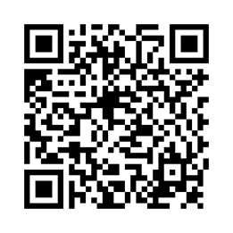

- The survey for Caregivers of seniors
Tuxedo Caregiver Survey
Or… Pick one up at the Town Hall or Tuxedo Park Library.

